1)ALTER TABLE

1)Add a new column linkedin_profile to employees table to store LinkedIn URLs as varchar.

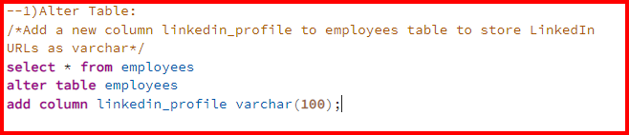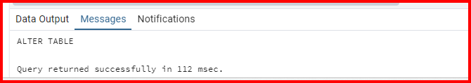2)Change the linkedin_profile column data type from VARCHAR to TEXT.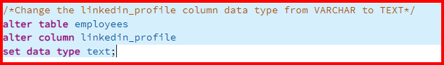

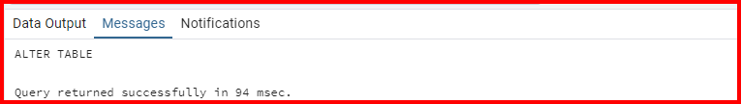

3)Add unique, not null constraint to linkedin_profile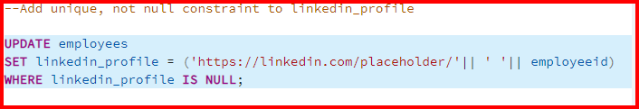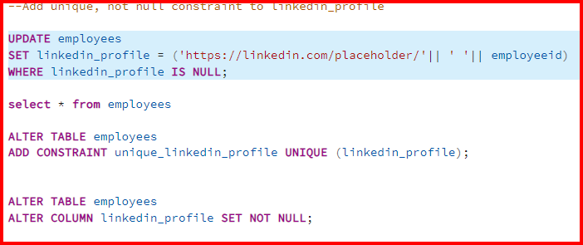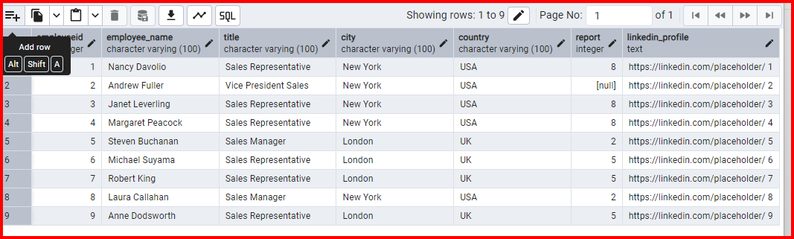4) Drop column linkedin_profile

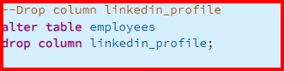

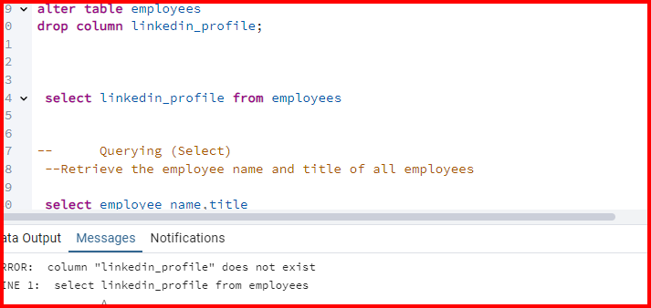

2.Querying (Select)

1)Retrieve the employee name and title of all employees

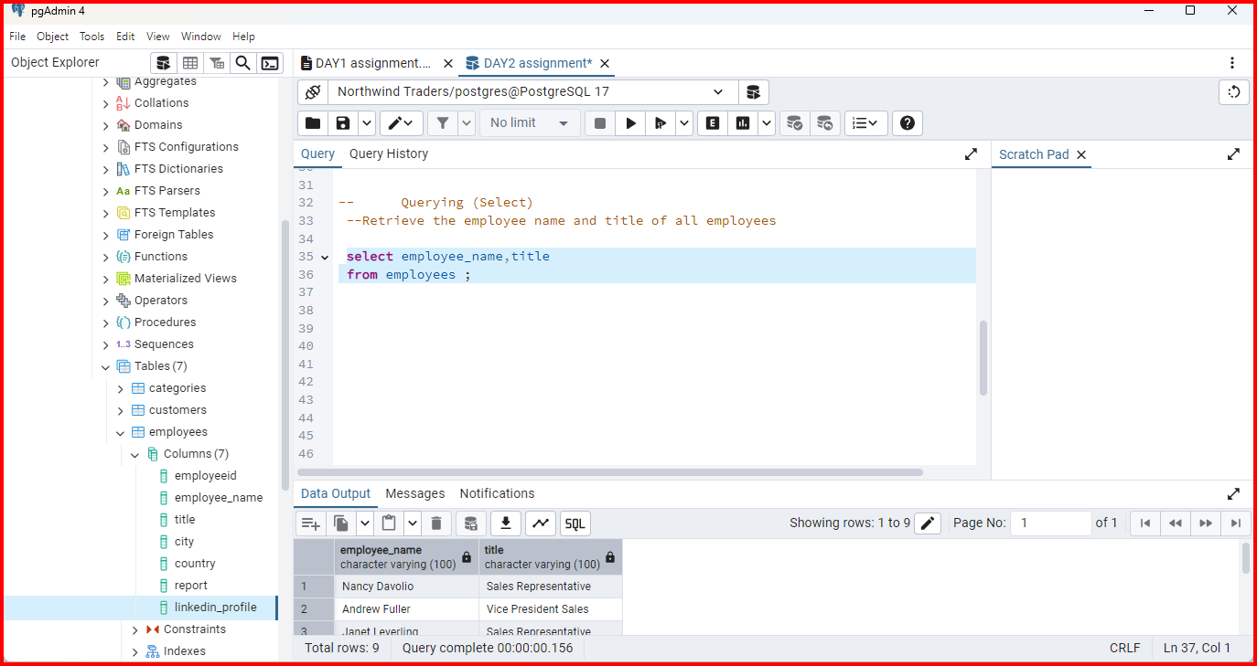

2) Find all unique unit prices of products

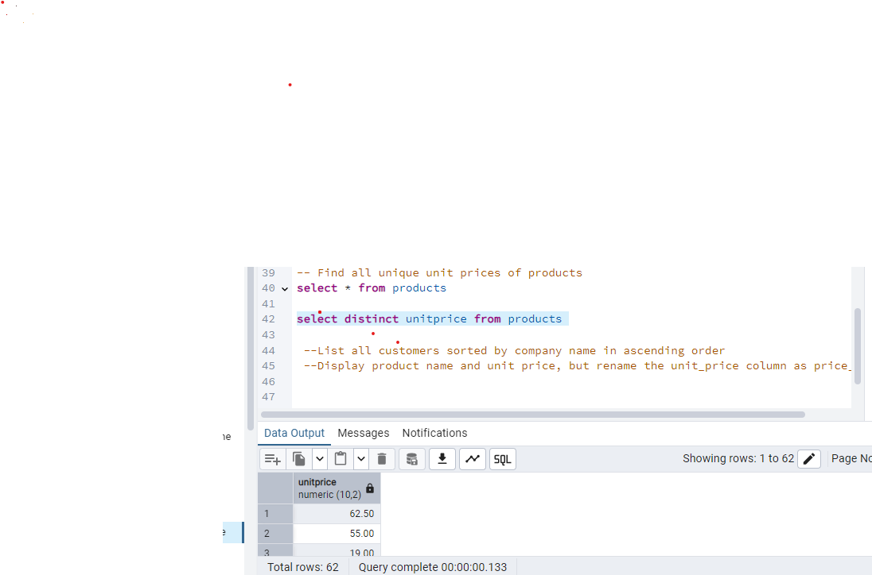

3)List all customers sorted by company name in ascending order

Query:

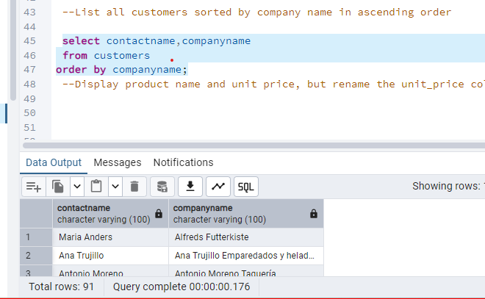

* 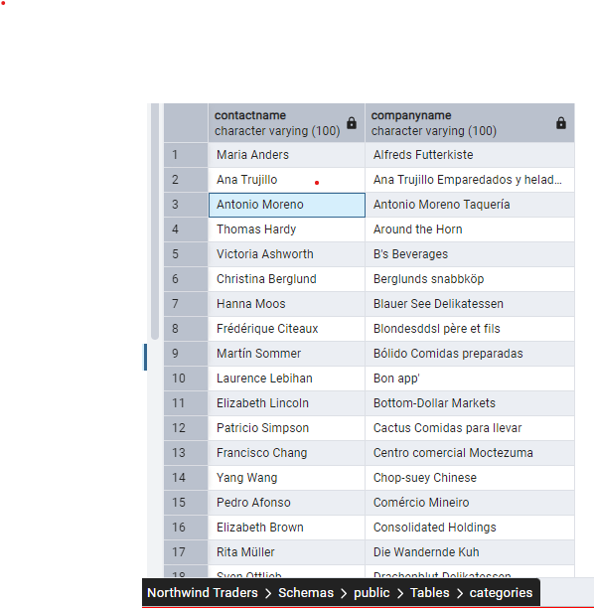

4)Display product name and unit price, but rename the unit_price column as price_in_usd

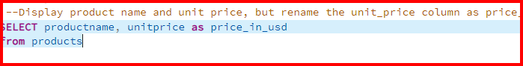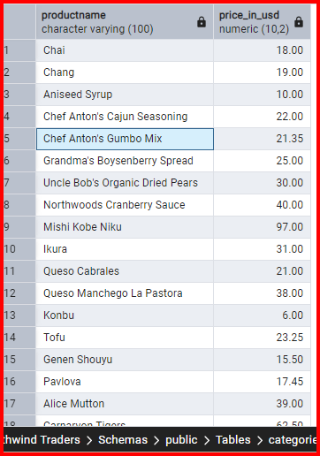

3)Filtering

* Q1) Get all customers from Germany.
* 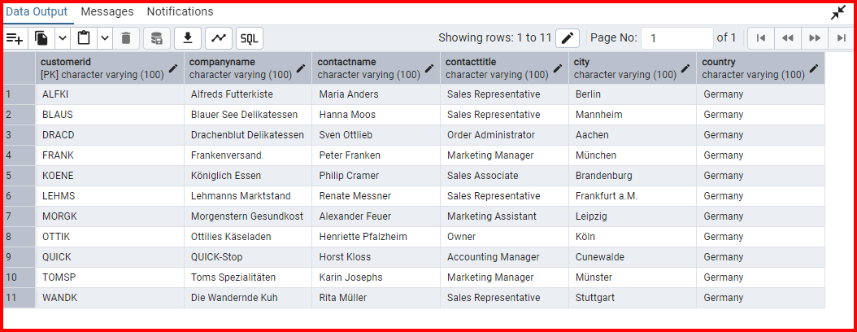

Q2)Find all customers from France or Spain

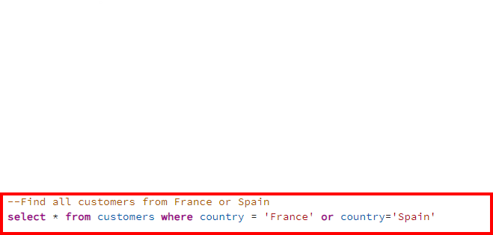

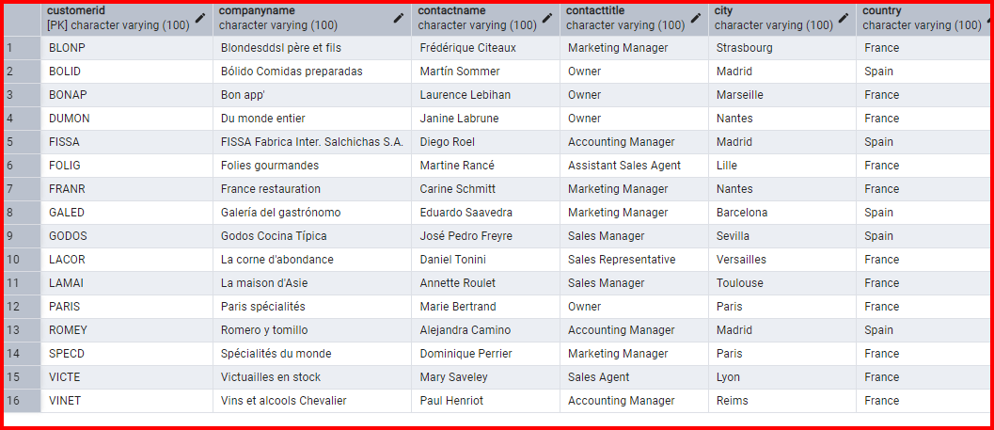

Q3) Retrieve all orders placed in 2014(based on order_date), and either have freight greater than 50 or the shipped date available (i.e., non-NULL) (Hint: EXTRACT(YEAR FROM order_date))



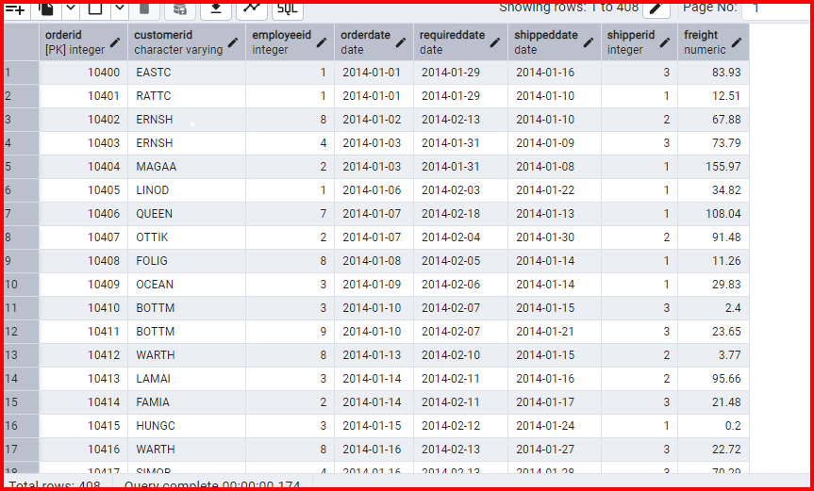

4) Filtering

1) Retrieve the product_id, product_name, and unit_price of products where the unit_price is greater than 15.

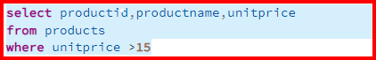

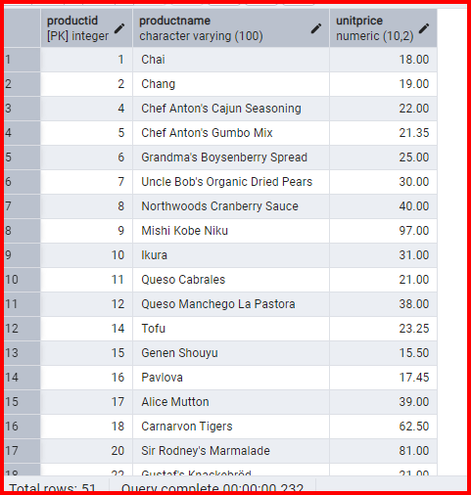

2) List all employees who are located in the USA and have the title "Sales Representative".

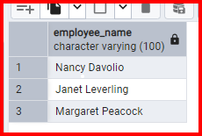

3) Retrieve all products that are not discontinued and priced greater than 30.

* 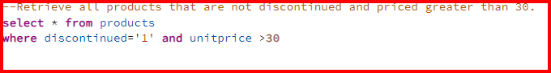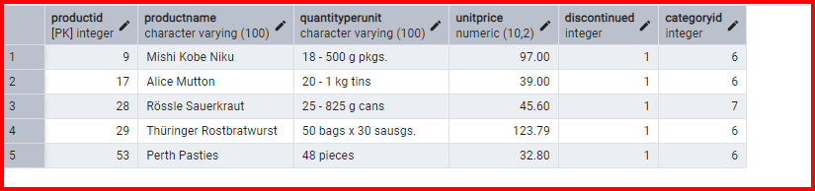

5)LIMIT/FETCH

1) Retrieve the first 10 orders from the orders table.



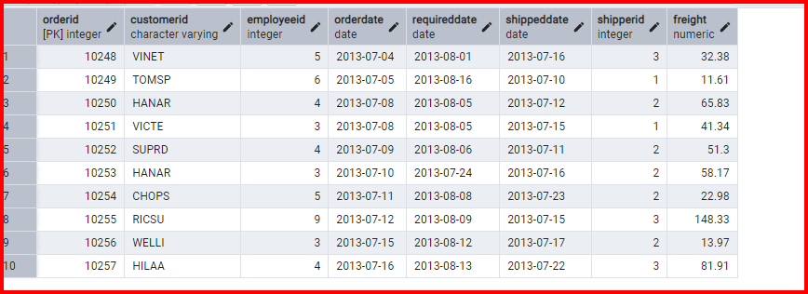

2)Retrieve orders starting from the 11th order, fetching 10 rows (i.e., fetch rows 11-20).

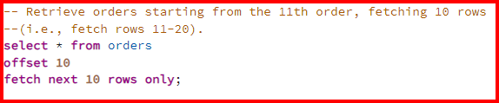

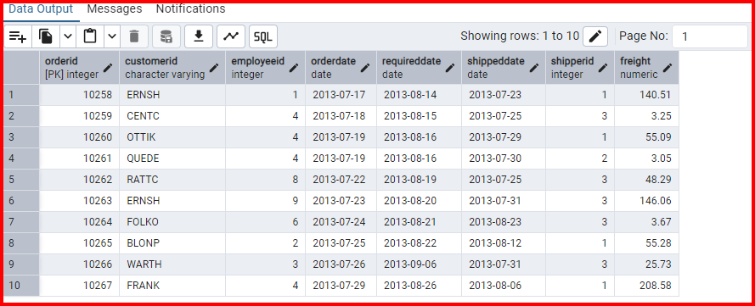

6)Filtering (IN, BETWEEN)

1)List all customers who are either Sales Representative, Owner

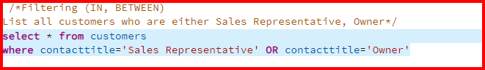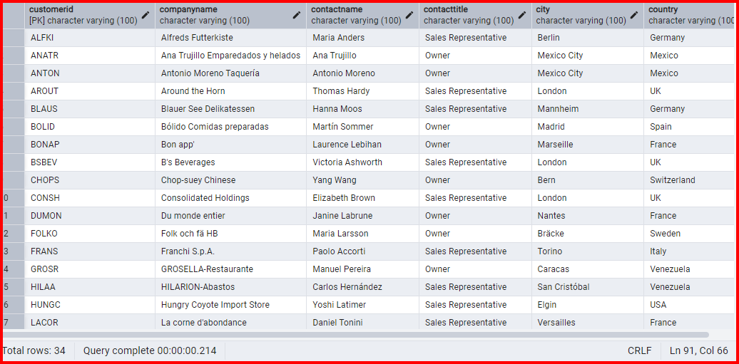

2)Retrieve orders placed between January 1, 2013, and December 31, 2013.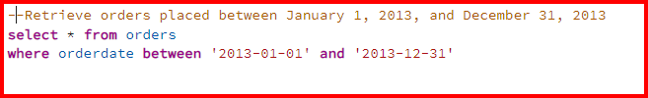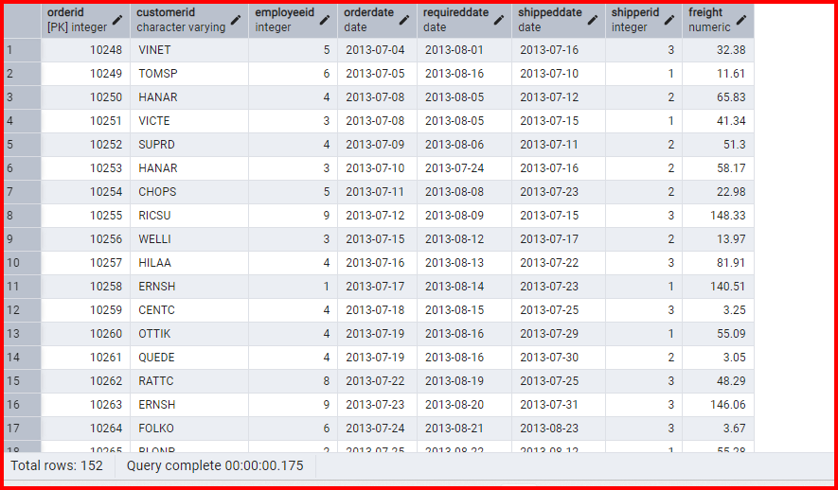

7)Filtering

1) List all products whose category_id is not 1, 2, or 3.

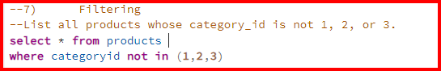

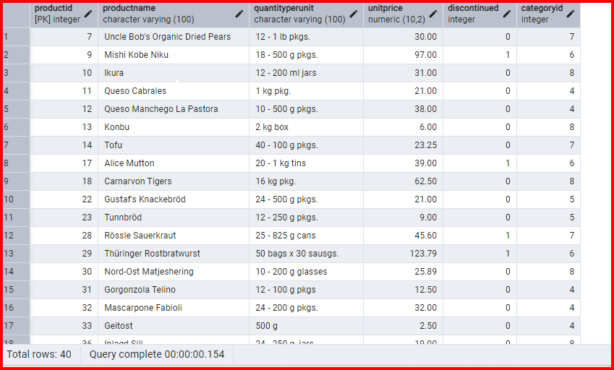

2) Find customers whose company name starts with "A".

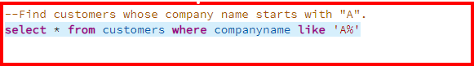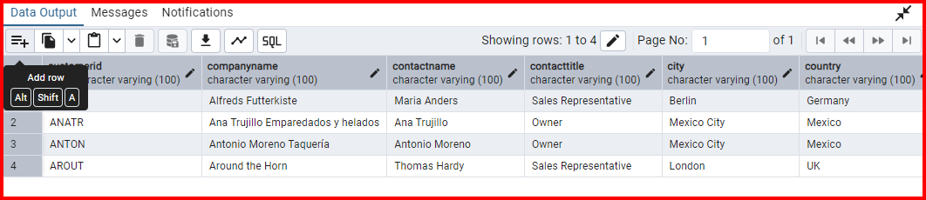

8)

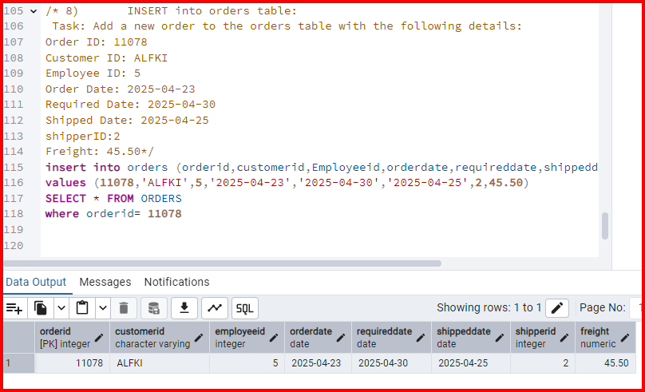

9) Increase(Update) the unit price of all products in category_id =2 by 10%.

(HINT: unit_price =unit_price * 1.10)

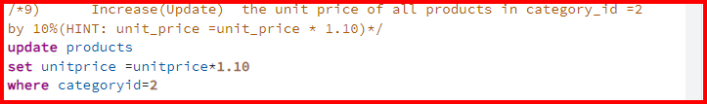

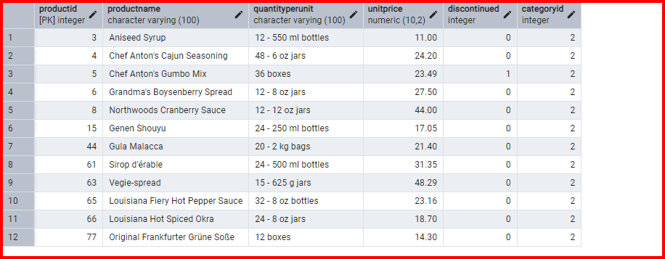

10) Sample Northwind database